**Lab Title:** Lab Setup

**Student Name:** Victoria Simon Omaojo

**Student ID:**

**Course Name:** Advanced Threat Intelligence

**Instructor Name:** Mr Aminu Idris

**Date of Submission:** [13/02/2025]

**Version:**

**LAB SETUP FOR MALWARE ANALYSIS**

**1.0. Executive Summary**

This lab assignment focuses on the installation and configuration of FLARE-VM, a virtual machine environment tailored for reverse engineering and malware analysis. The key activities include setting up a Windows 10 virtual machine, disabling security features that may interfere with the installation, and executing the FLARE-VM installation script. The lab also emphasizes the importance of isolating the environment to prevent accidental execution of malware outside the controlled lab. This step by step lab configuration will ensure a fully functional FLARE-VM environment ready for advanced cybersecurity operations.

**1.1. Lab Objectives**

The primary objectives of this lab are:

1. To set up a Windows 10 virtual machine using VirtualBox.
2. To disable Windows Update and Windows Defender to ensure a smooth installation process.
3. To install FLARE-VM using PowerShell scripts.
4. To configure the virtual machine for isolated malware analysis.
5. To document the installation process, including challenges and solutions.

**1.2. Tools and Resources Used**

* **VirtualBox**: A free and open-source virtualization tool used to create and manage virtual machines.
* **Windows 10 ISO**: The operating system installed on the virtual machine.
* **FLARE-VM**: A collection of software installation scripts for setting up a reverse engineering environment.
* **PowerShell**: A command-line tool used to execute the FLARE-VM installation script.
* **Guest Additions**: VirtualBox tools that enhance VM functionality, such as shared folders and full-screen mode.

**1.3. Methodology**

**Step 1: Installation of Windows 10 in VirtualBox**

1. The first thing is to download and install VirtualBox <https://www.virtualbox.org/wiki/Downloads>, since I already have virtual box installed, I moved to the next step.

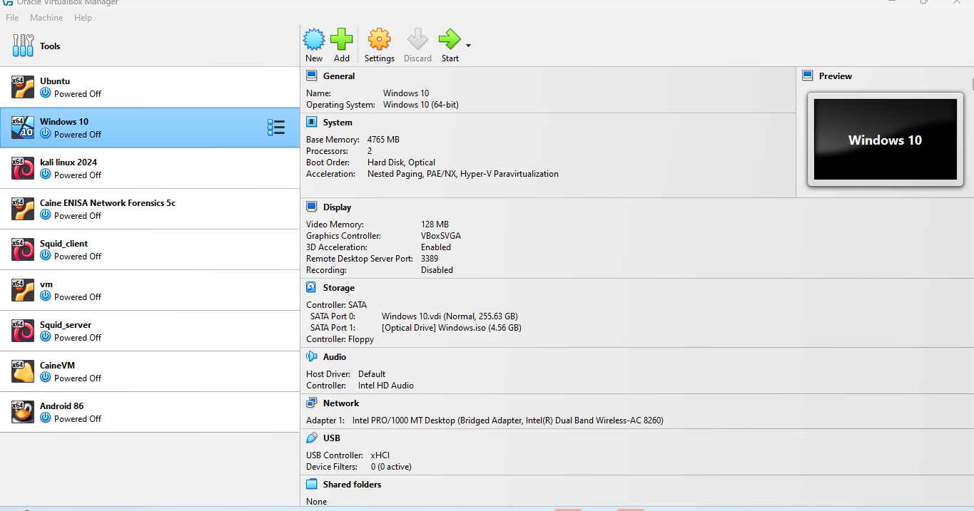

Figure 1: Installed Virtual Box, 2024 version

1. Downloaded windows 10 image from <https://www.microsoft.com/en-us/software-download/windows10>

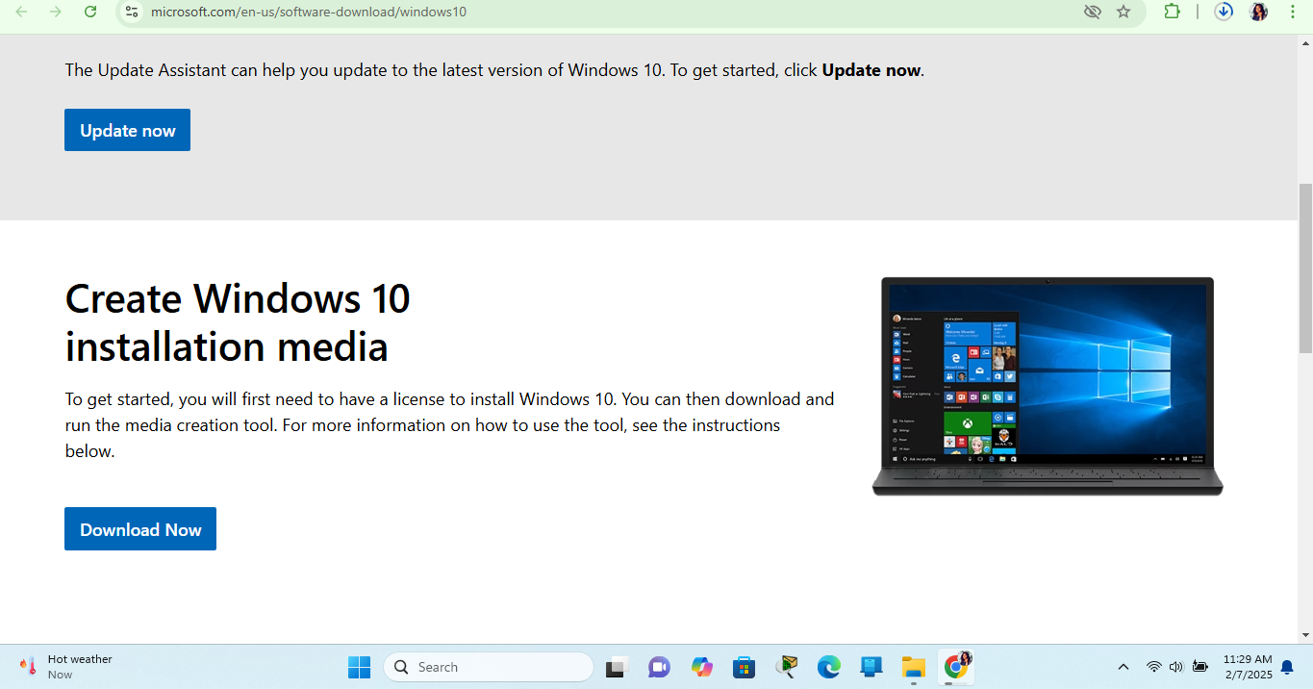

Figure 2:Creating windows 10 installation media

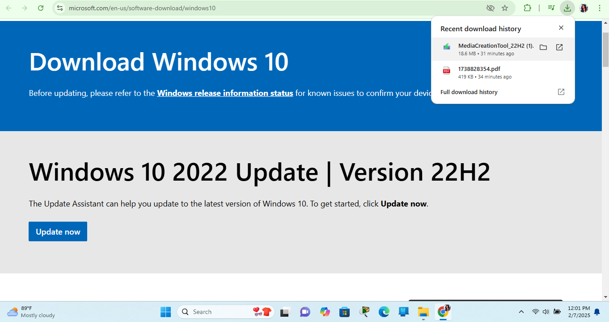

Figure 3: downloaded windows image.

1. Clicked the downloaded file to start installation by following the setup wizard, since my goal was to work with a virtual machine, I selected the image type to an ISO.

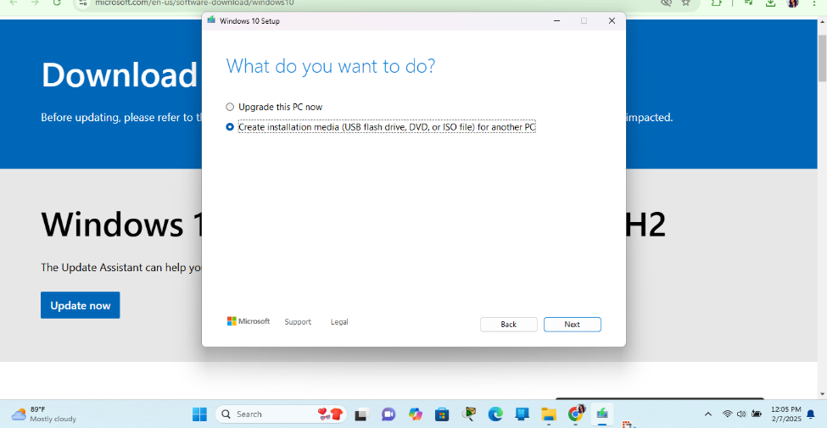

Figure 4: showing the objective of the image

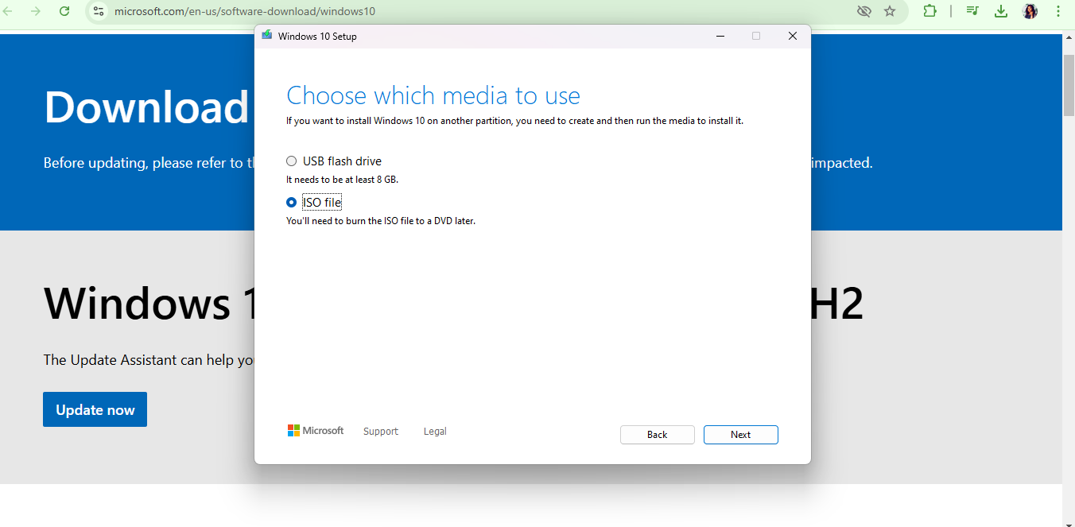

Figure 5: showing the selected ISO file

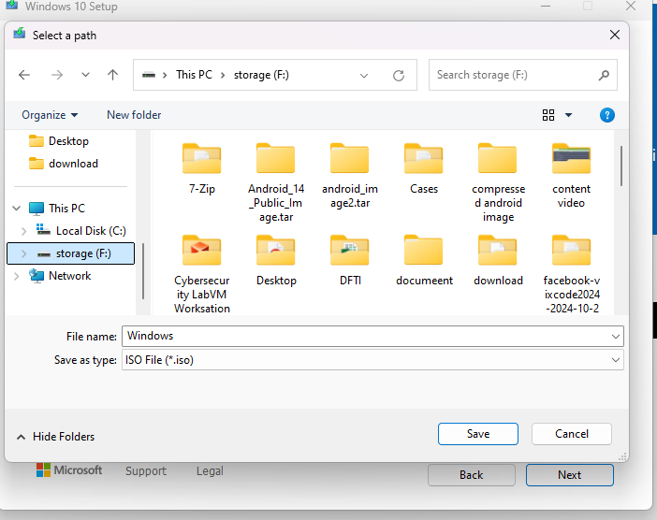

Figure 6: selected ISO File Location

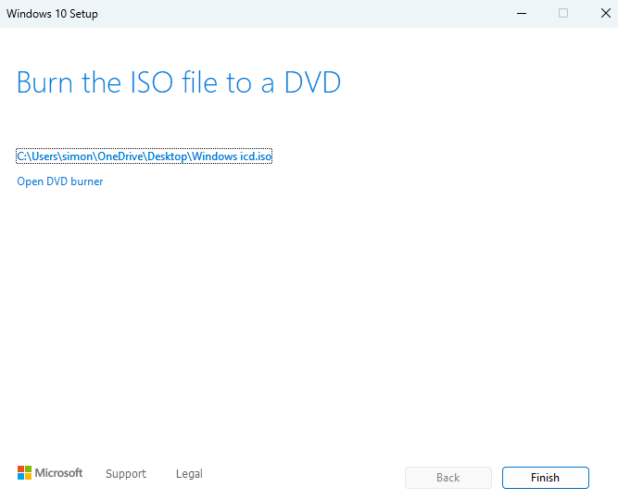

Figure 7: final stage of windows 10 image creation

1. To create a new windows 10 virtual machine and allocate at least 2 GB of RAM and 60 GB of disk space: I follow these steps:
   * + Open virtual Box >> click on New>> set up the name>> select the folder >> select the windows ISO you just created>> select type as Microsoft windows>> select version as windows 10 >> check the “skip unattended installation” >> click finish, as shown in the figure 8 and 9.

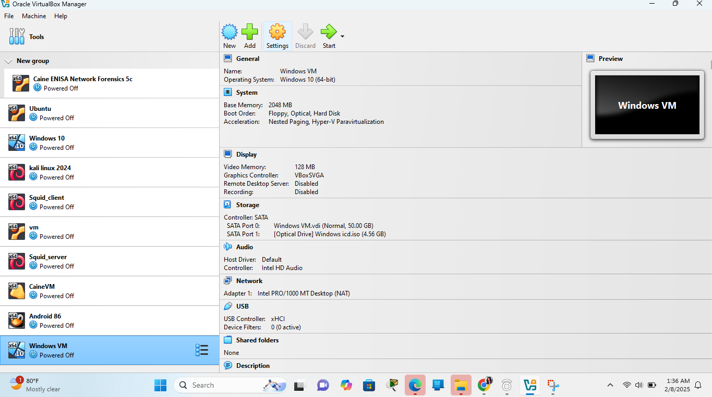

Figure 8:Virtual machine interphase

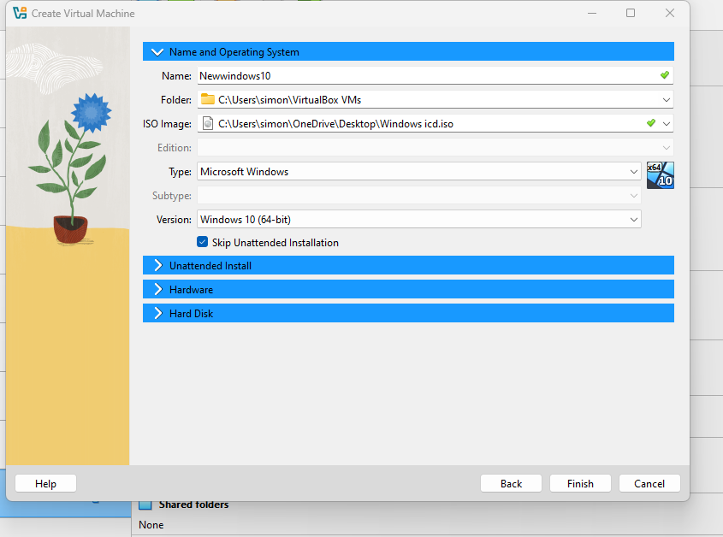

Figure 9: Showing the Name and other Configuration of the Virtual machine



Figure 10: New windows 10 created

1. Clicked on the setting to ensure the Disk capacity of at least 60 GB and memory of at least 2GB.
   * 1. Under General, changed the shared clipboard and drag and drop to bidirectional
     2. System>> Based memory to 4gb >> Processor to minimum 2( avoiding the red line)
     3. Display>> video memory to 128
     4. Storage >> above 70GB

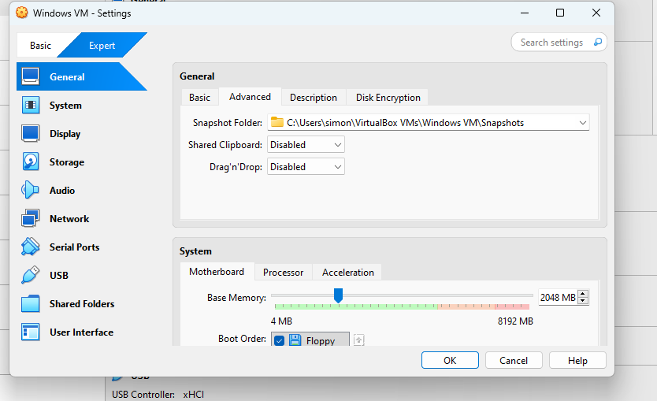

Figure 11:General setting

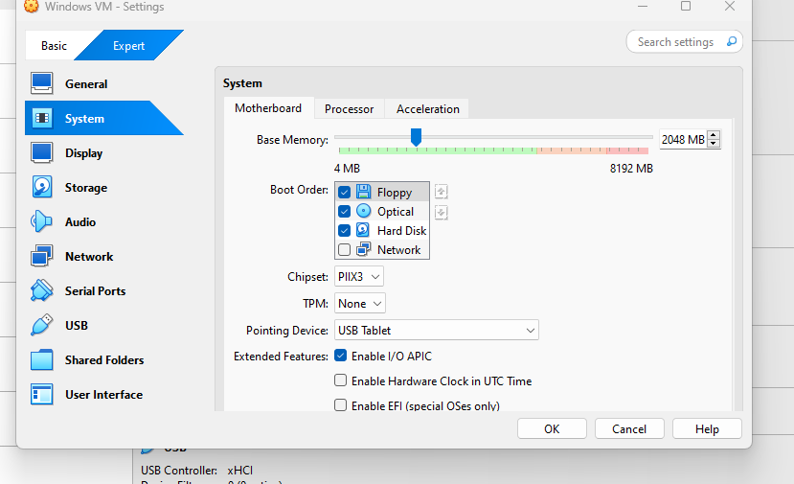

Figure 12: System setting for motherboard

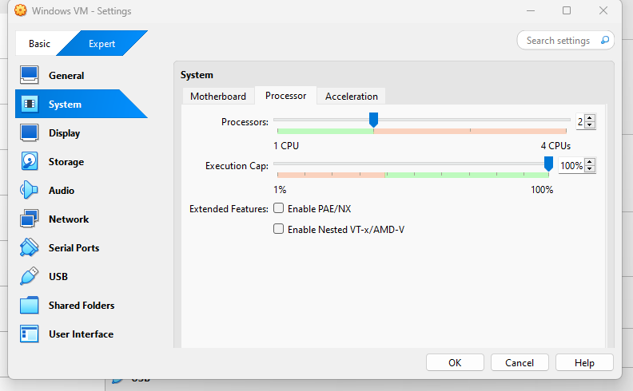

Figure 13: System settings for Processor

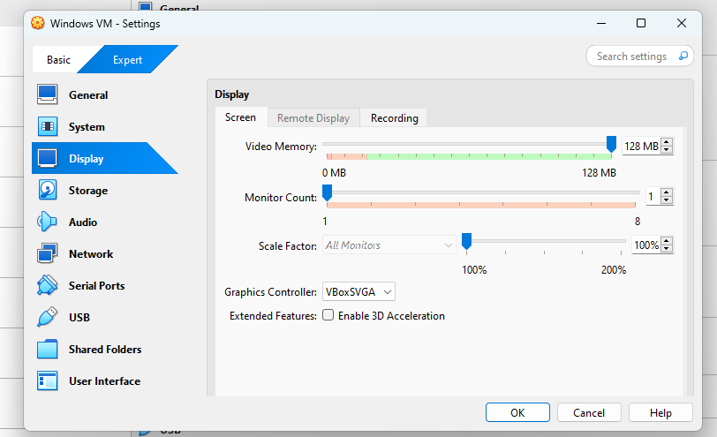

Figure 14: Display setting

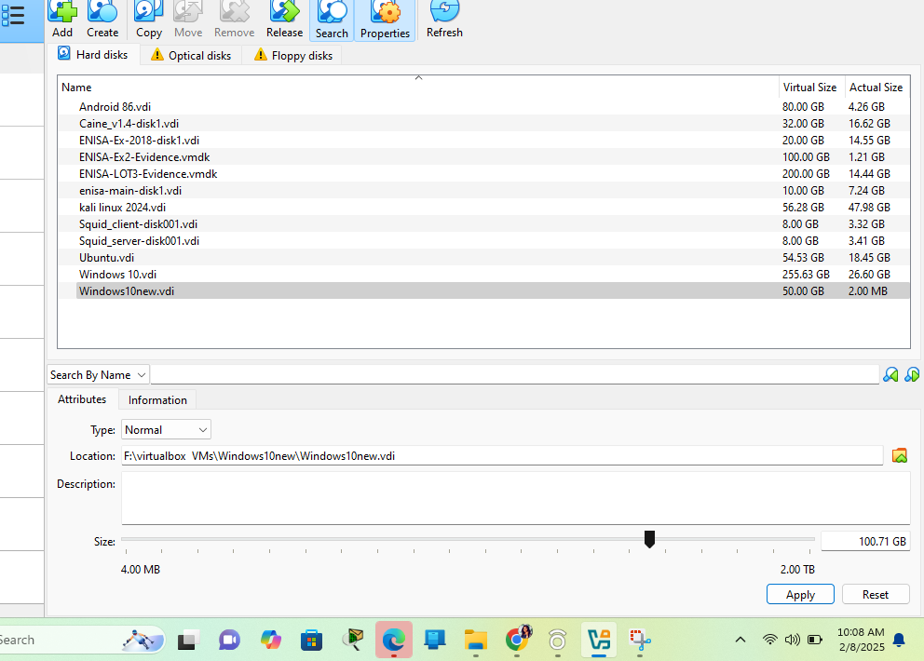

Figure 15: setting the storage capacity of the newly created windows machine from the tool icon

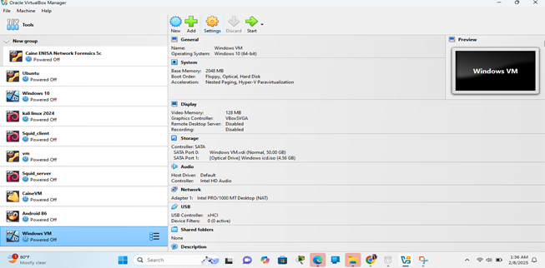

Figure 16: Start the windows machine

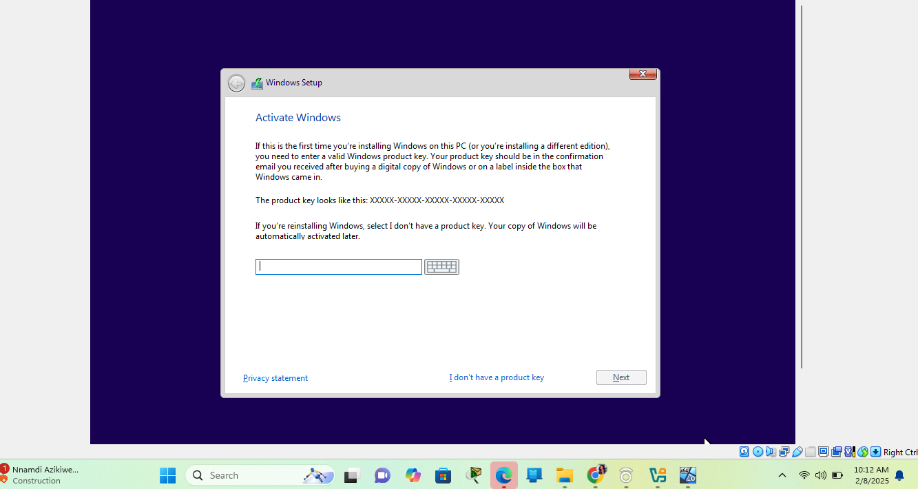

Figure 17: Selected I don’t Have a product key

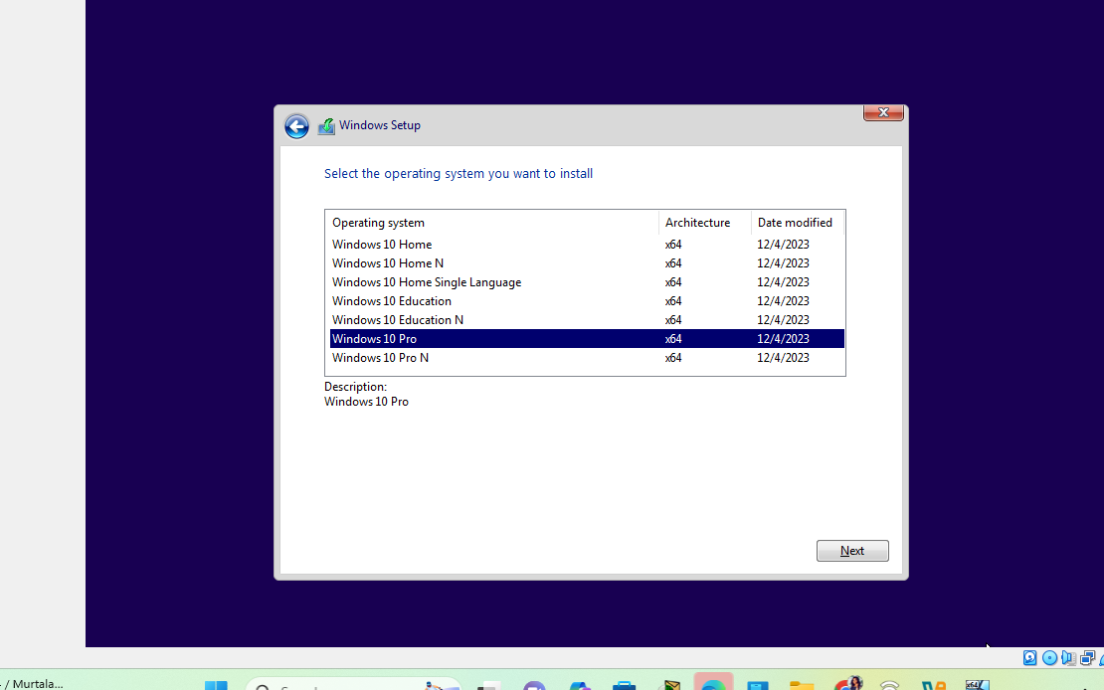

Figure 18: Selected Windows 10 PRo

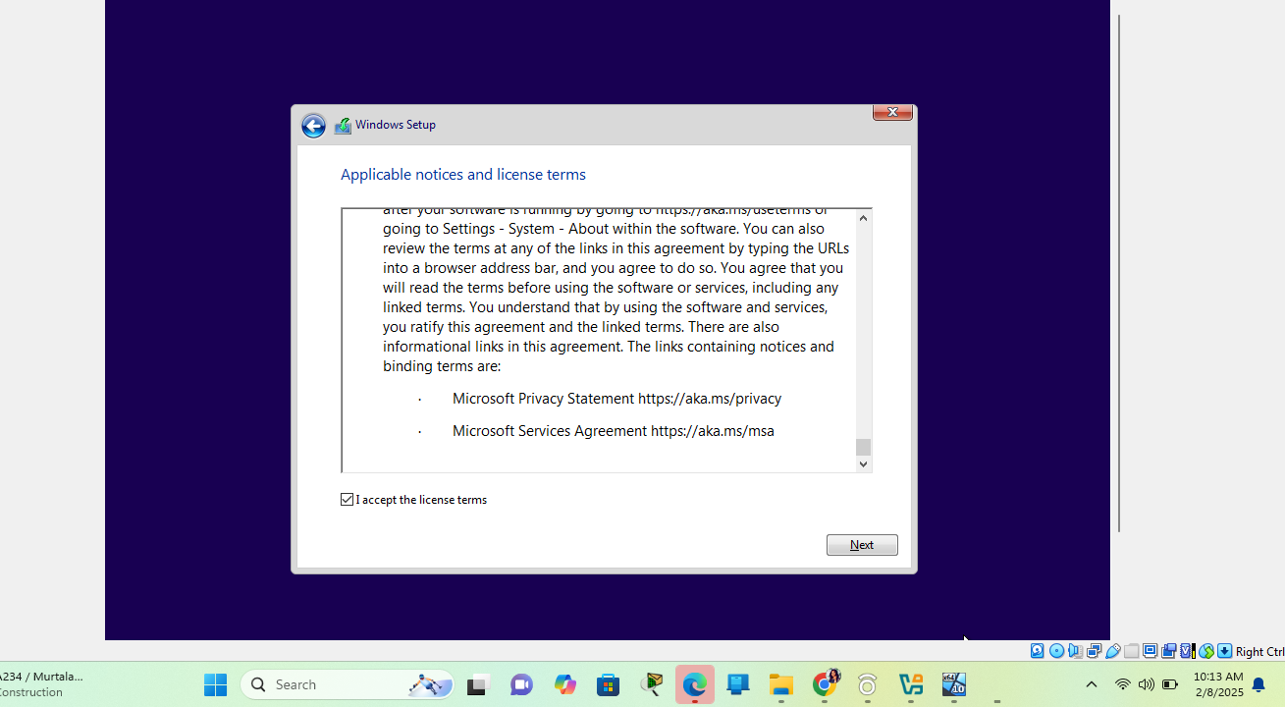

Figure 19: Checked “Accept the licence terms”

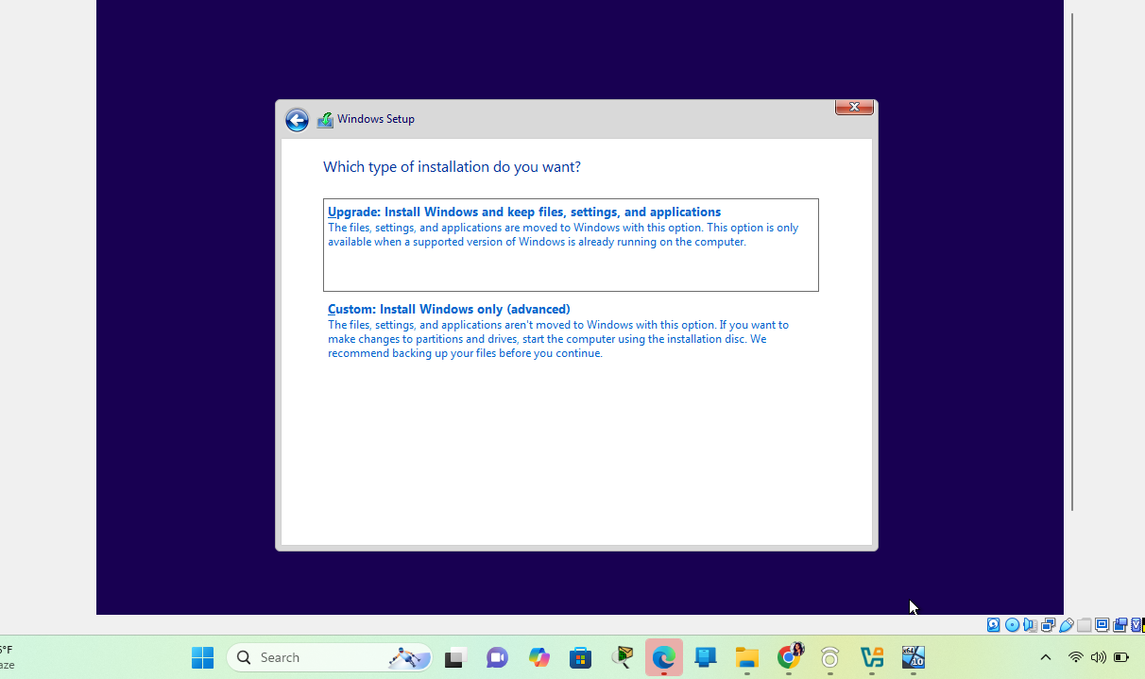

Figure 20: Selected “ custom Installation”

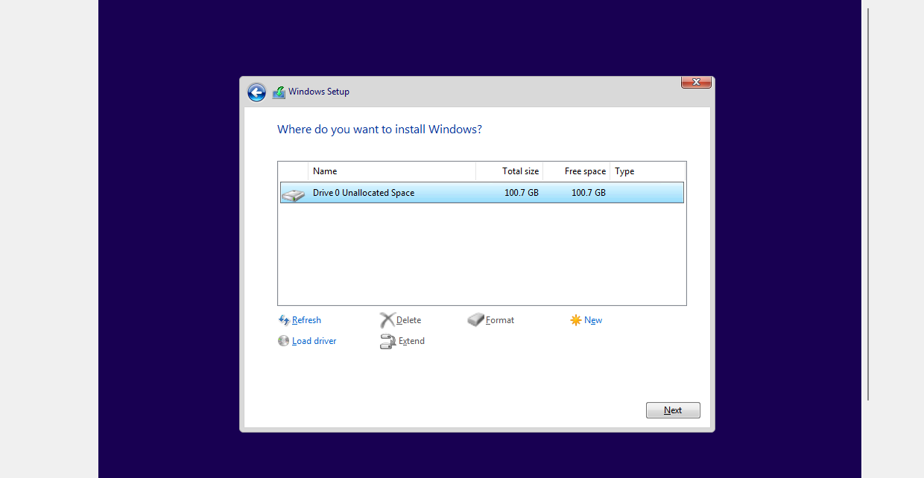

Figure 21: Selected the disk Partition

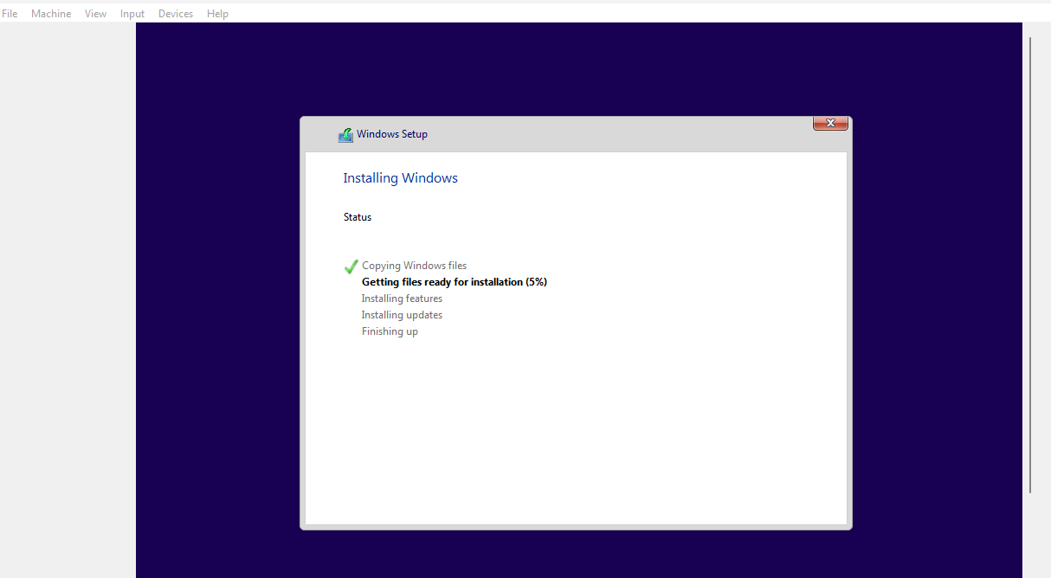

Figure 22: Installation Progress

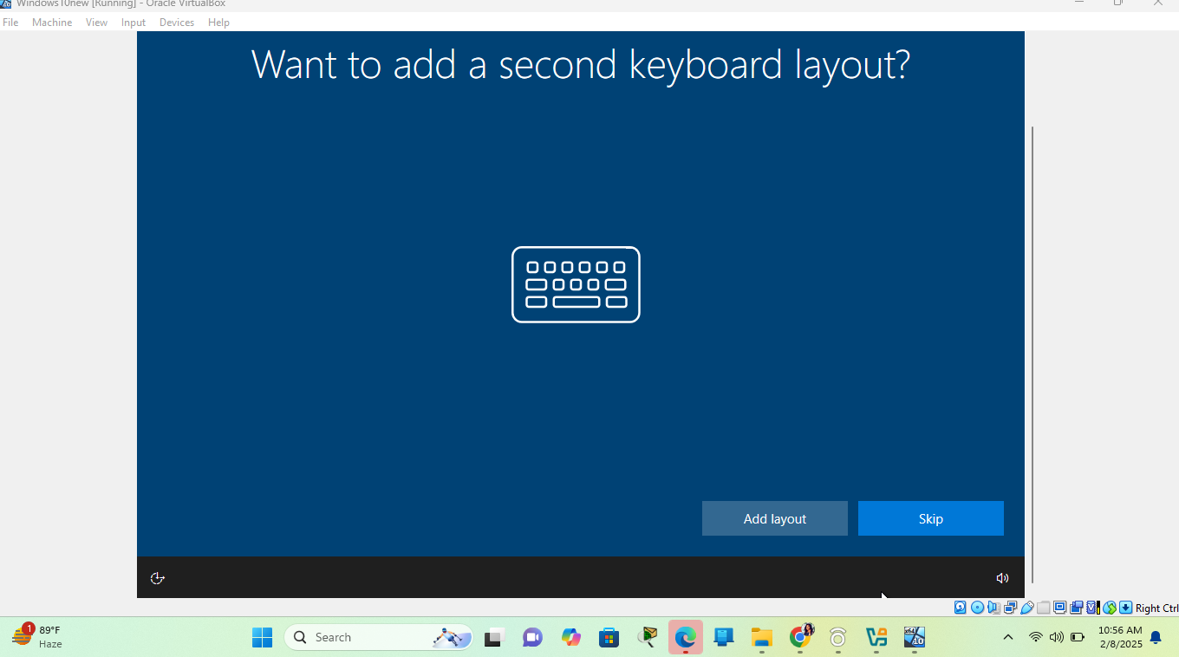

Figure 23: Windows keyboard setup (selected my Region and my keyboard type to US)

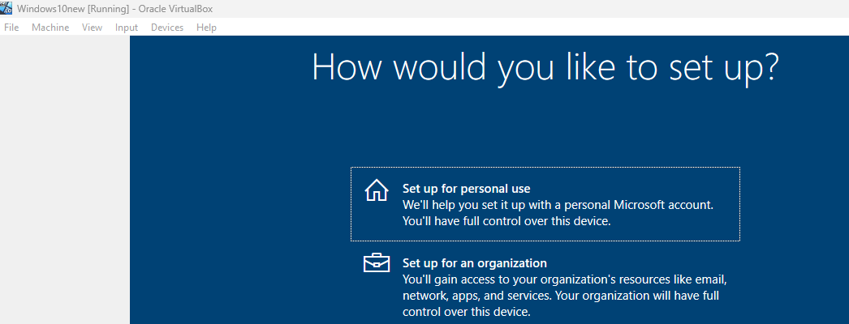

Figure 24:Selected Personal Use

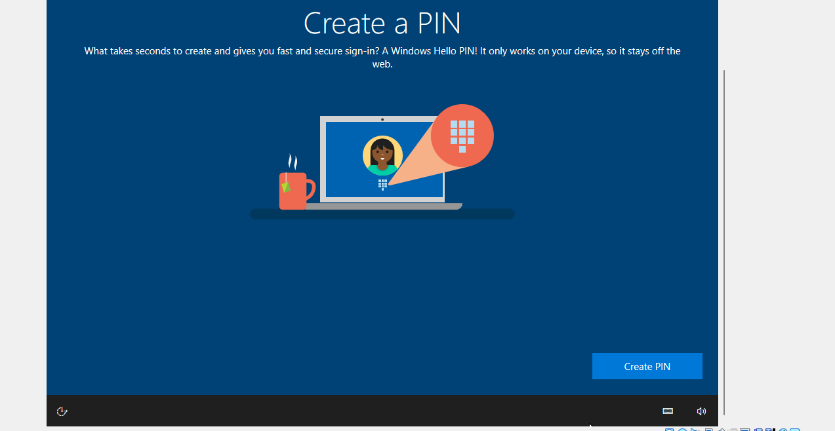

Figure 25: Created my pin

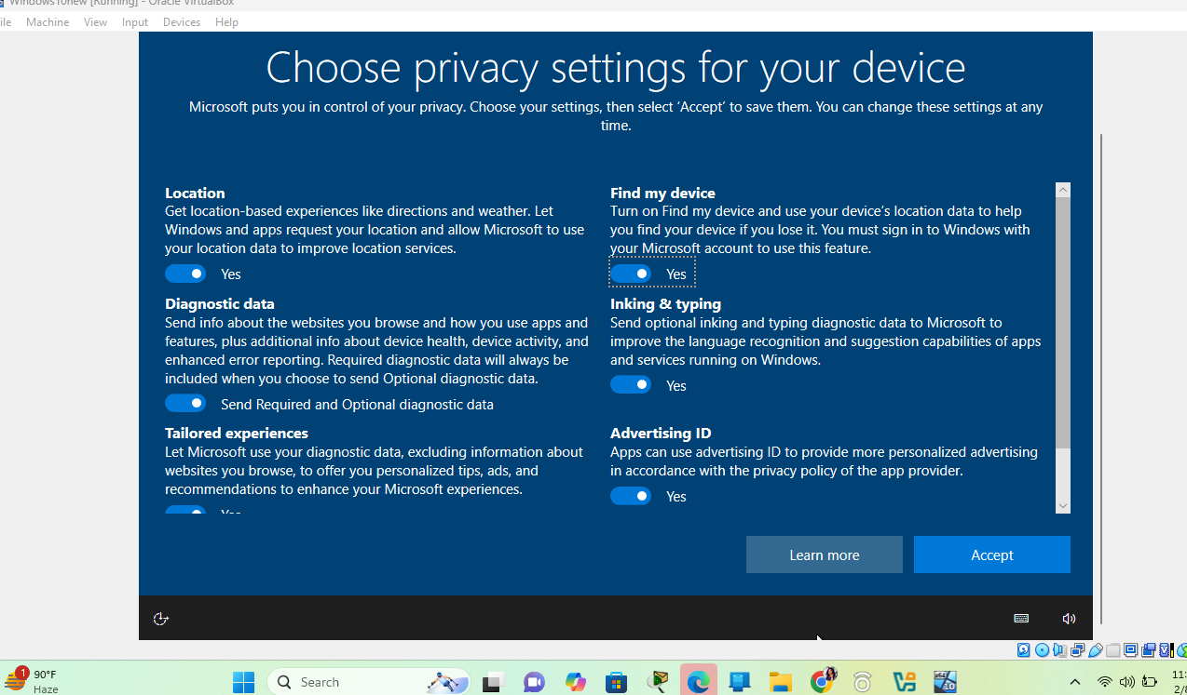

Figure 26:Select the Accept

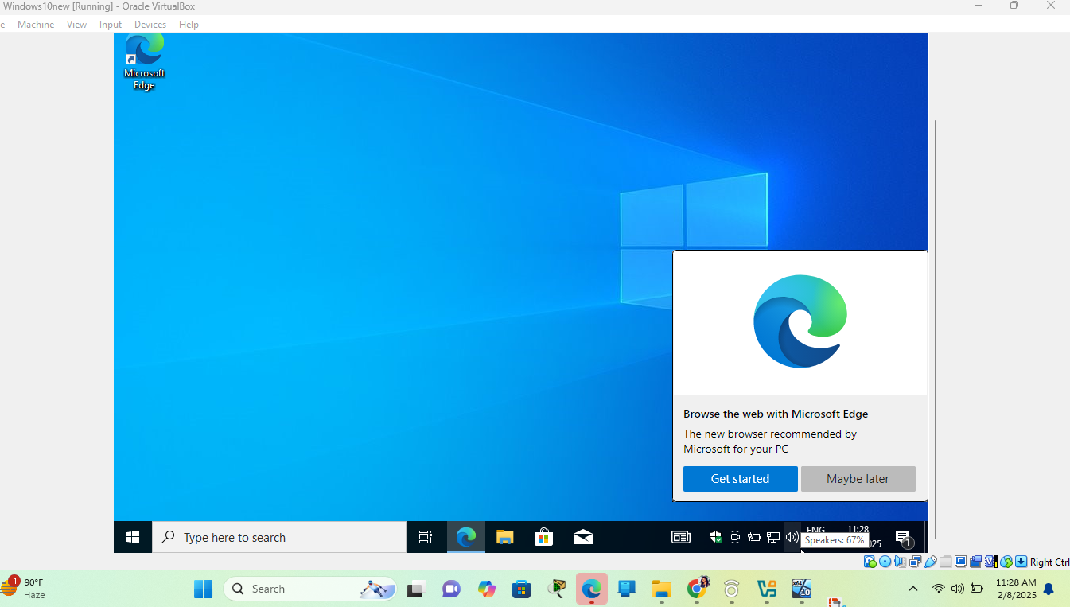

Figure 27: Windows VM fully installed

**Step 2: Install Guest Additions**

1. I clicked on the **Devices > Insert Guest Additions CD Image**.

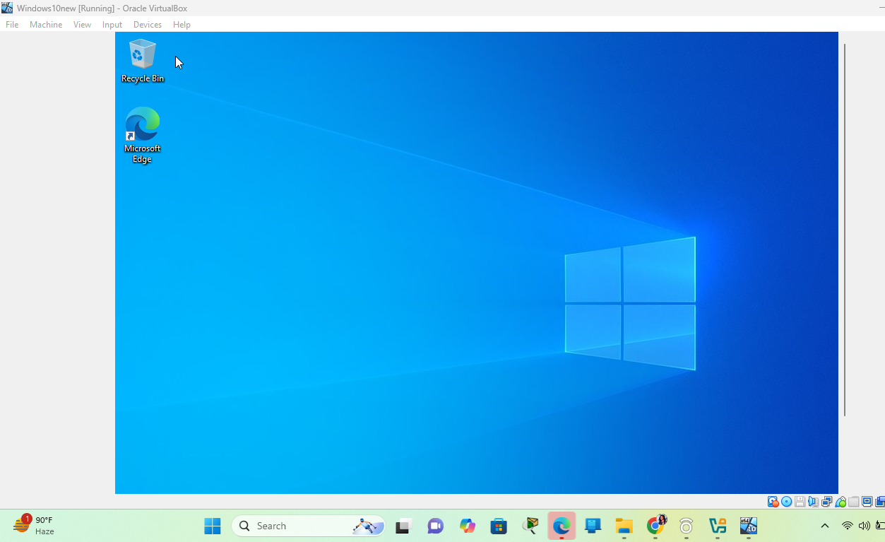

Figure 28:Guest additions installation

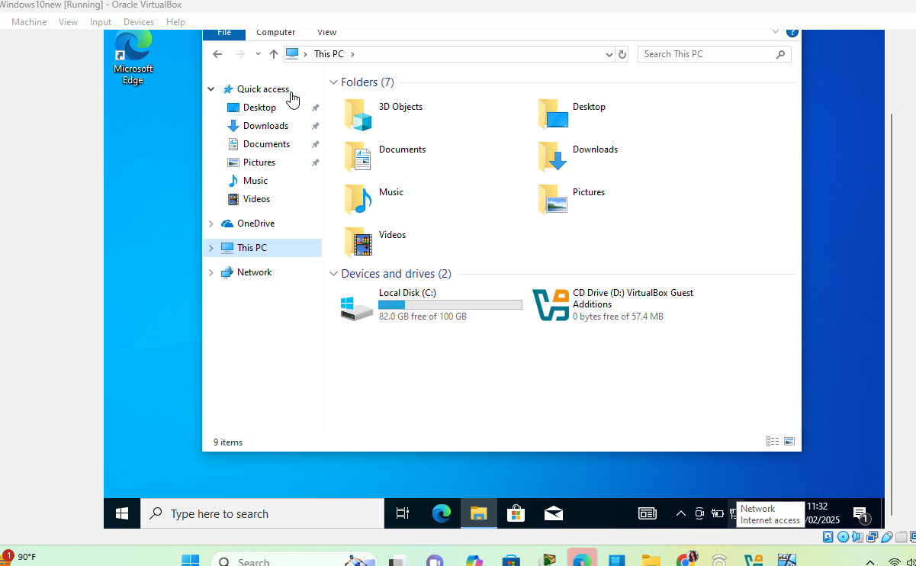

Figure 29:Installing through the file explorer

1. From the file explorer, I right click >> open the file

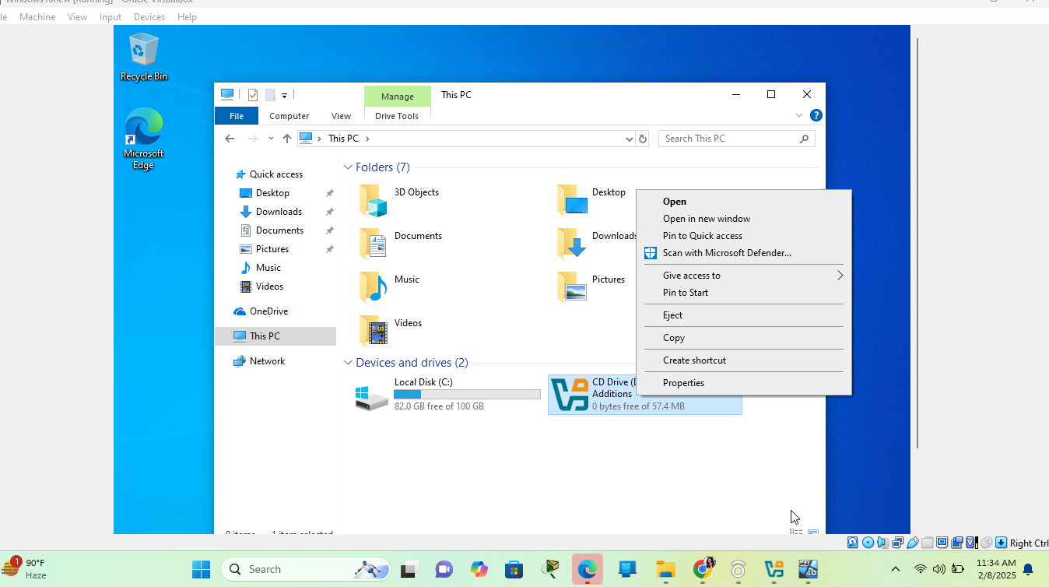

Figure 30: Guest additions Installation

1. Ran the installer from the CD drive>> accept the setup wizard to enable full-screen mode and shared folders.

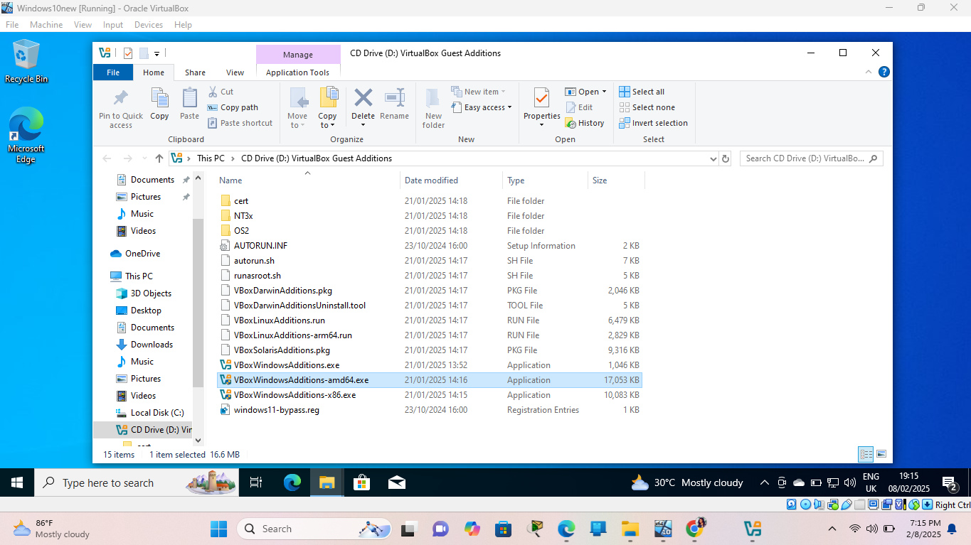

Figure 31:Selected installer package

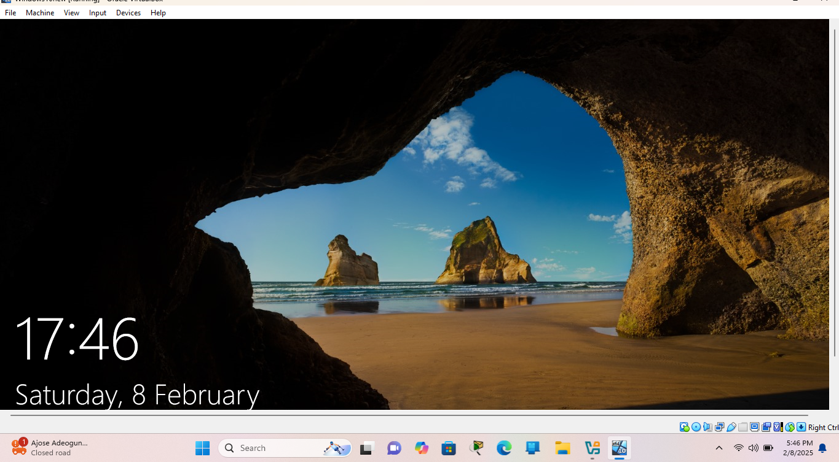

Figure 32: Windows after reboot

**Step 3: Configure the VM**

1. Disable Windows Update using the instructions a
2. To disable automatic updates on Windows 10 permanently, I followed these steps:
3. Opened **Start**.
4. Searched for **gpedit.msc** and click the top result to launch the **Local Group Policy Editor**.

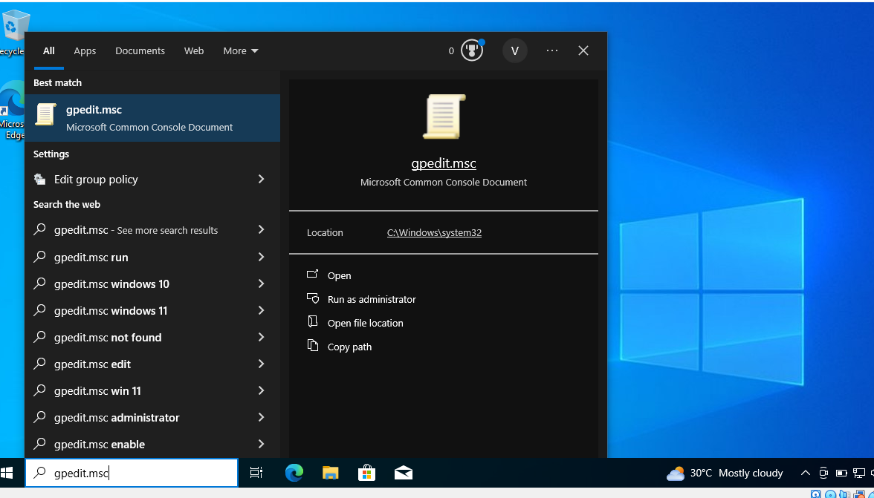

Figure 33 lauching gpedit

1. Navigated to the following path: ***Computer Configuration > Administrative Templates > Windows Components > Windows Update***
2. Double-clicked the **"Configure Automatic Updates"** policy on the right side.

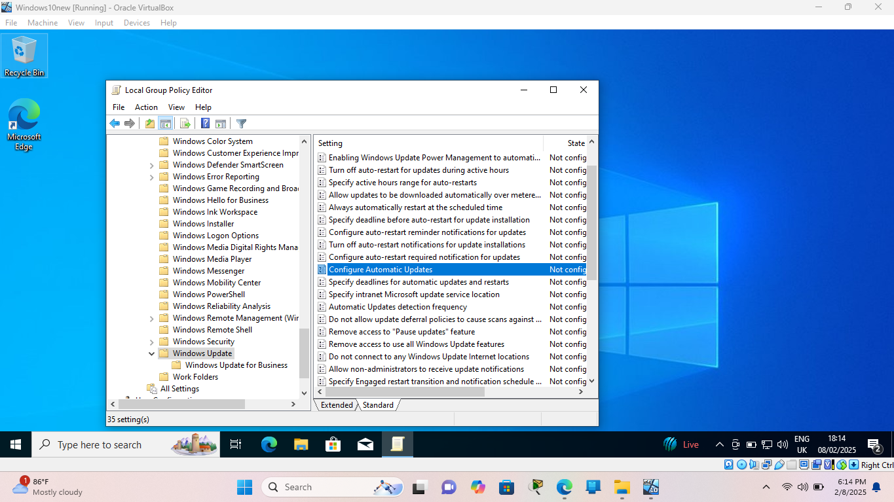

Figure 34: Group policy editor configuration to disable windows update

1. Check the **Disabled** option to turn off automatic Windows 10 updates permanently.

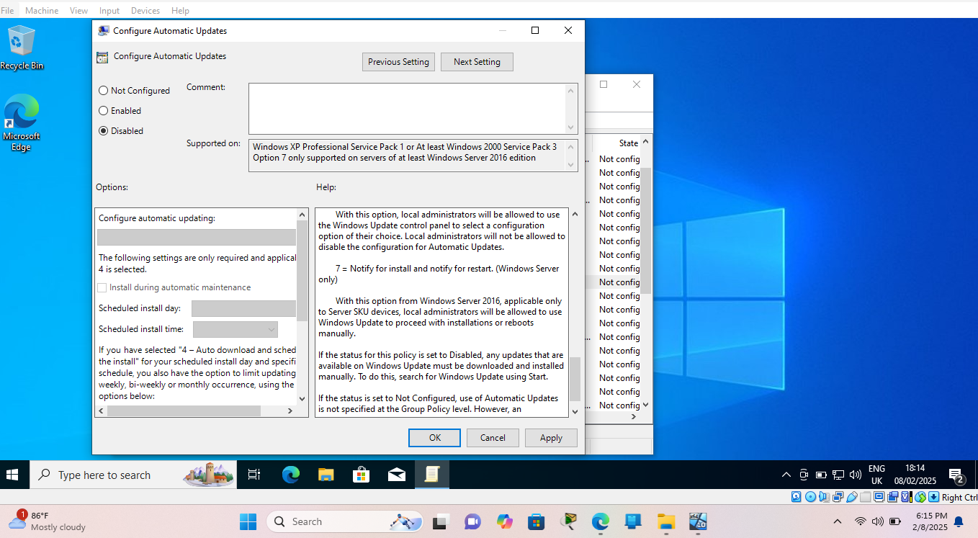

Figure 35: Disabled windows update

1. Clicked the **Apply** button.
2. Clicked the **OK** button.
3. Disabled Windows Defender using Group policy, third party application and manual methods.
4. Opened Windows Security by typing Windows Security in the search box)
5. Navigated to Virus & threat protection > Virus & threat protection settings > Manage settings
6. Switched Tamper Protection to Off

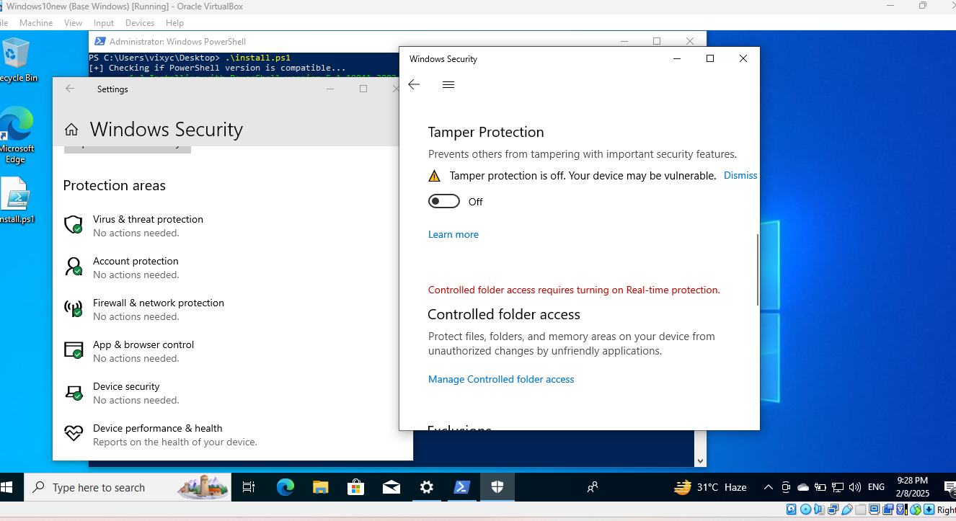

Figure 36: turned of tamper protection from windows security

**To permanently disable real-time protection:**

1. Opened Local Group Policy Editor (type gpedit.msc in the search box)
2. **Computer Configuration > Administrative Templates > Windows Components > Microsoft Defender Antivirus > Real-time Protection**
3. Enable Turn off real-time protection

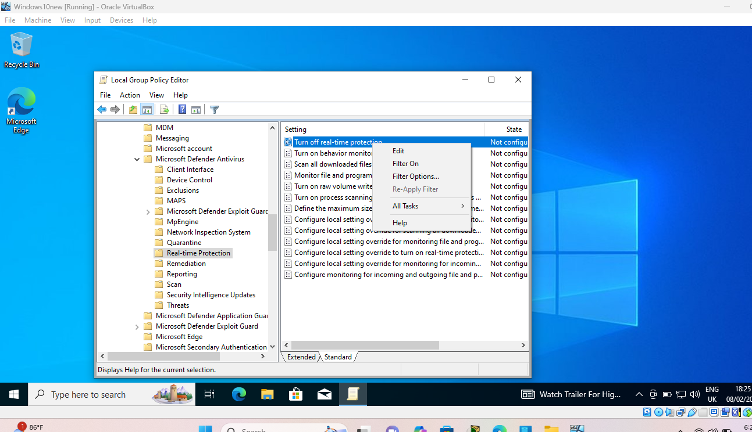

Figure 37: turning off Real-time Protection

**To permanently disable windows defender service protection on windows 10 pro that I installed.**

This was achieved by downloading a third-party application called **defender control**, using this website. [Defender Control v2.1](https://www.sordum.org/9480/defender-control-v2-1/).

1. From the windows virtual machine, I opened the browser
2. Downloaded 7zip
3. pasted the link to download the software file
4. unzipped the file using 7zip and imputing the password the and run it, and then turn of windows defender.

[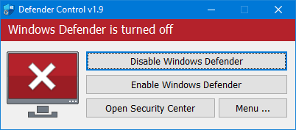](https://i.sstatic.net/ViIFs.png)

Figure 38b: Windows Defender turned off

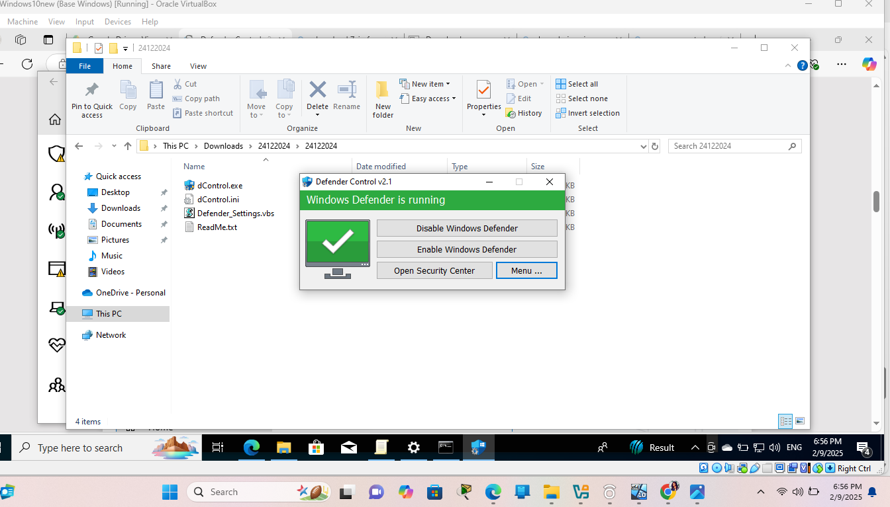

Figure 39: controller turned on

1. Show hidden files and extensions in File Explorer.
   1. Opened File Explorer (Win + E).
   2. Clicked on View > Options (on Windows 10).
   3. clicked the View tab.
   4. Uncheck Hide extensions for known file types.
   5. Select Show hidden files, folders, and drives.
   6. Click Apply and OK.

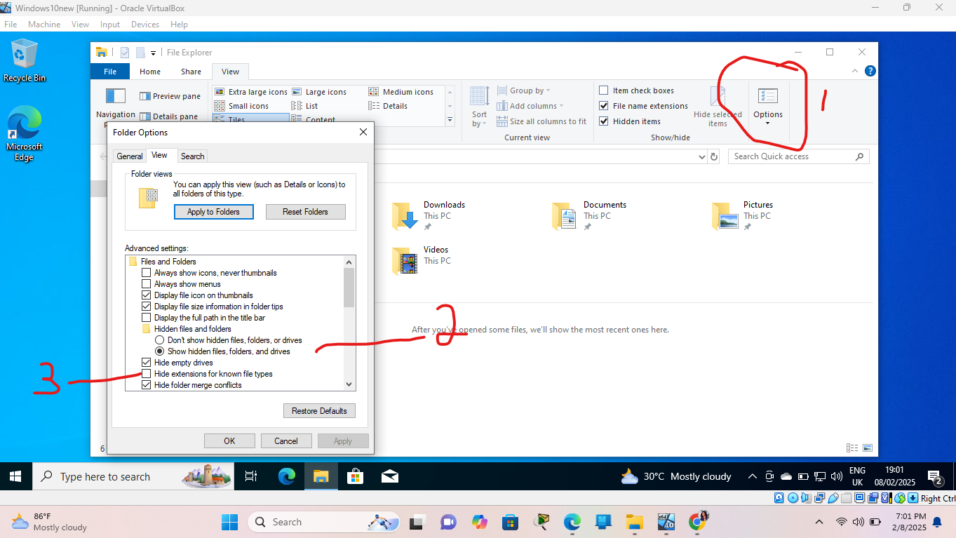

Figure 40: configure file explorer showing hinden files and extensions

1. REBOOT or RESTART the machine.
2. Take a snapshot of the VM in VirtualBox to save the current state.

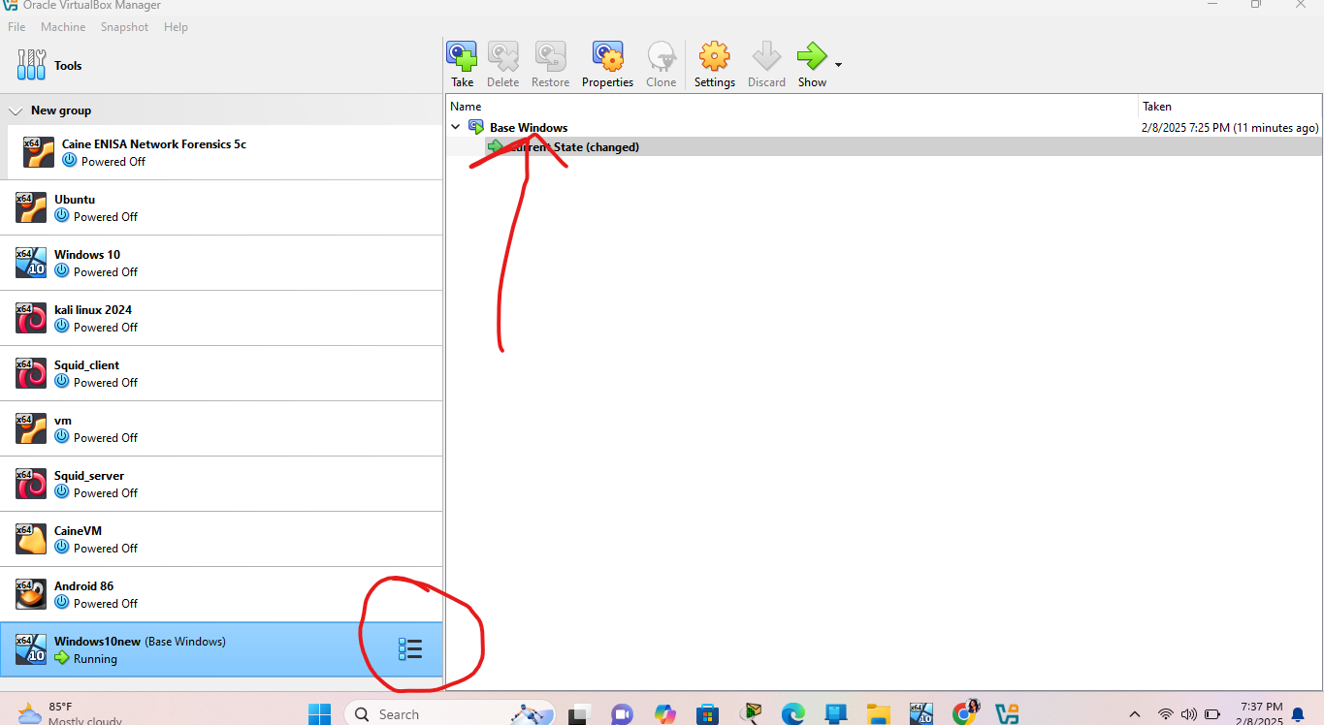

Figure 41:Saved snapshot

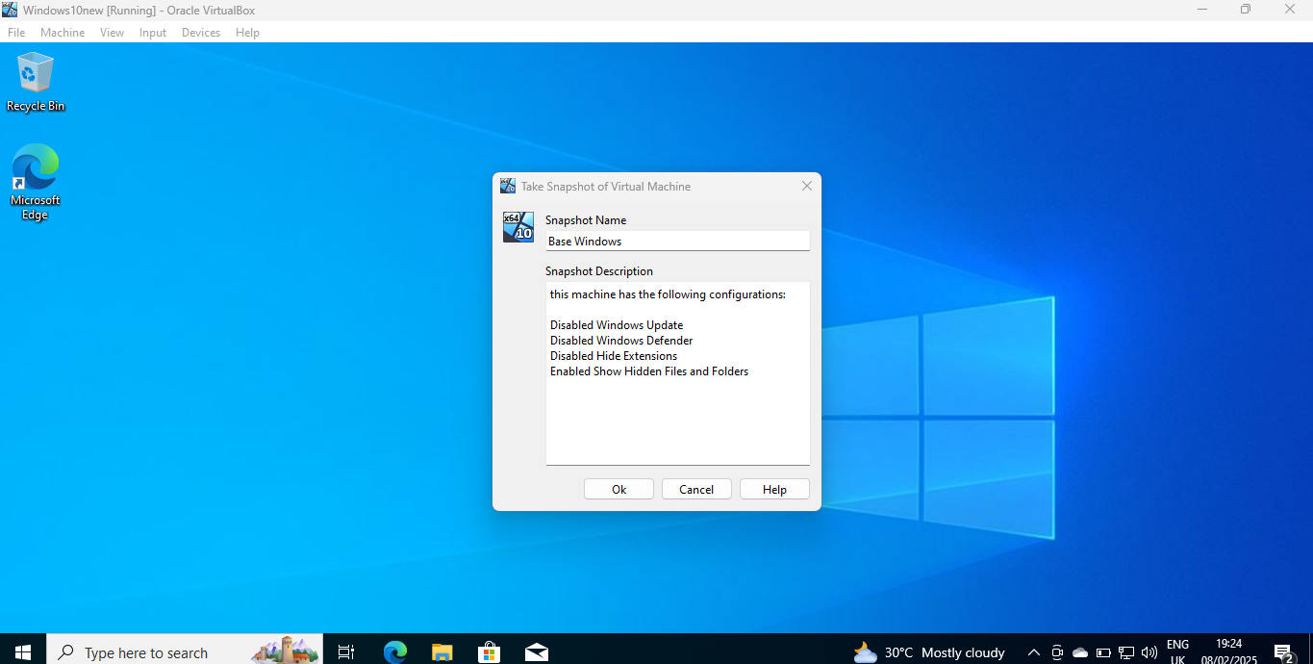

Figure 42:labeled snapshot

**Step 4: Install FLARE-VM**

To install the Flare Vm, those prerequisite steps above are very important. These were the steps I took to Install Flare VM on my newly configure Windows 10 machine. This process took 6-7hrs because my network was slow.

1. Open PowerShell as Administrator.
2. Download the FLARE-VM installation script:

(New-Object net.webclient).DownloadFile("https://raw.githubusercontent.com/mandiant/flare-vm/main/install.ps1", "$(Environment.GetFolderPath('Desktop'))\install.ps1")

(I ensured I cd to my /User/username/Desktop directory to avoid error message

1. Unblocked the script:

Unblock-File .\install.ps1

1. Enabled script execution:

Set-ExecutionPolicy Unrestricted -Force

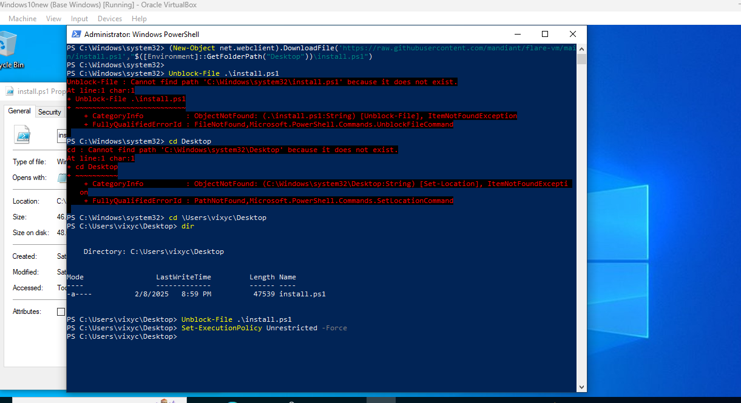

Figure 43: Administrative Powershell command interphase

1. Ran the installation script:

.\install.ps1

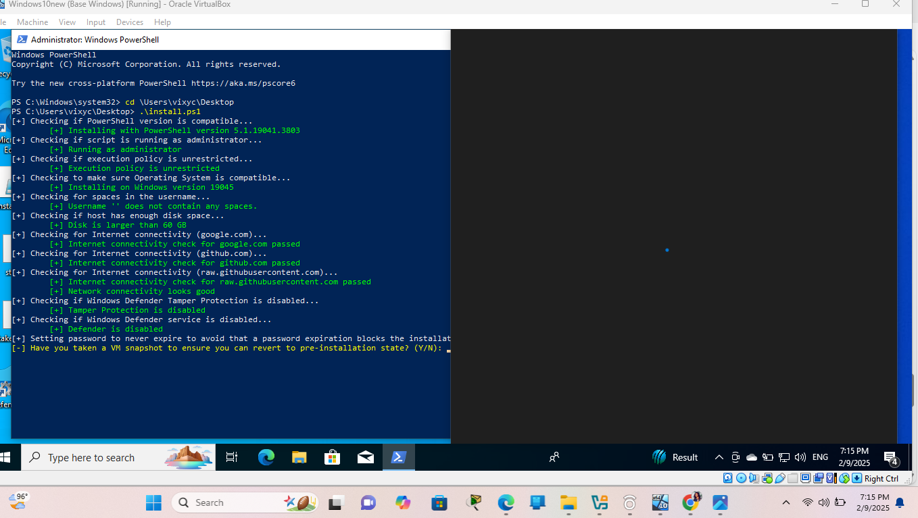

Figure 44: Flare VM Script installation checklist

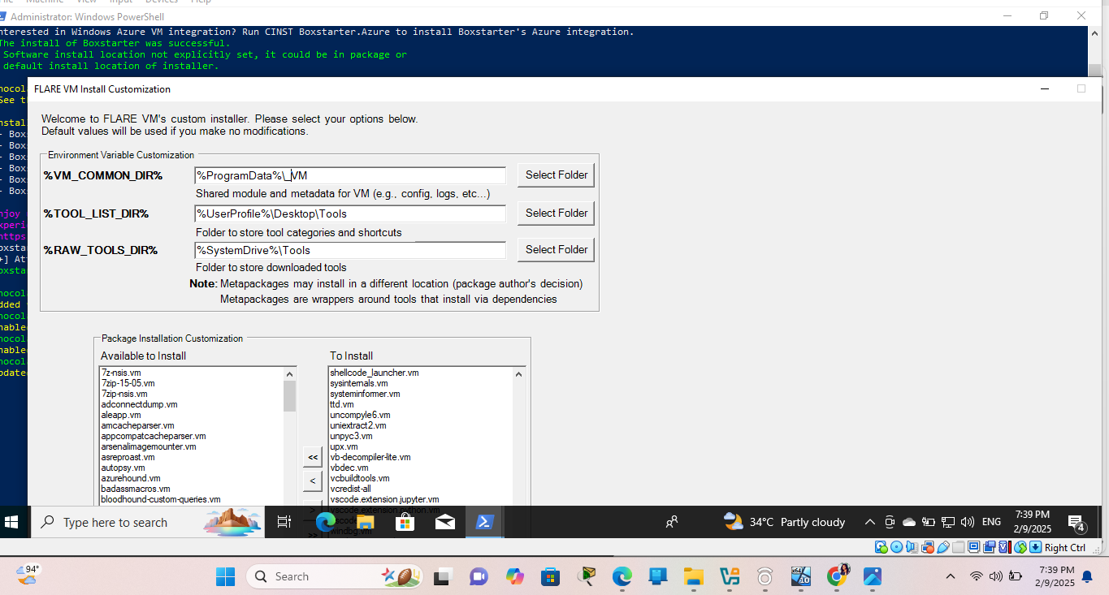

Figure 45: pop-up windows from the script. >> clicked enter to continue

The windows restarted and the powershell script continued (This happened severally during installation)

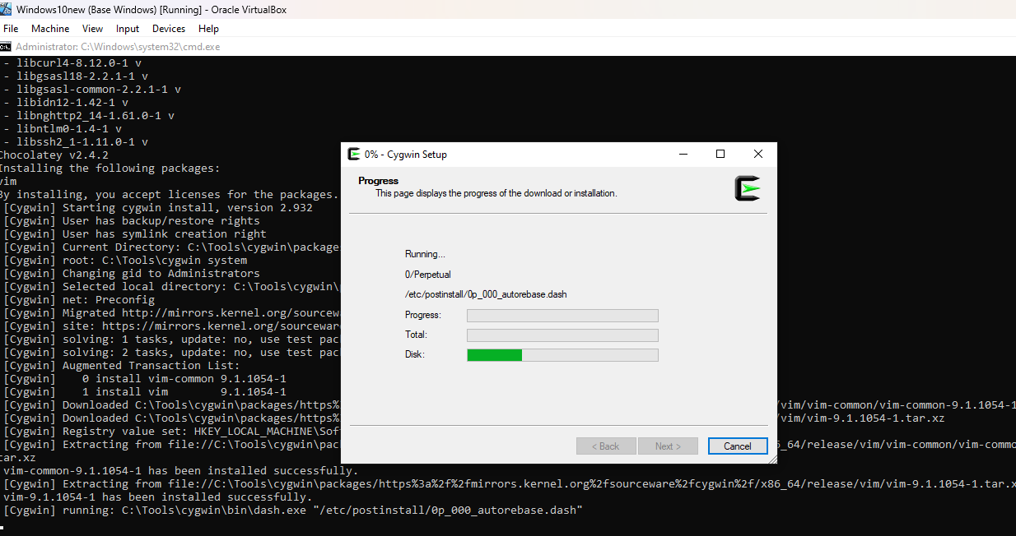

Figure 46:Flare VM tool Setup

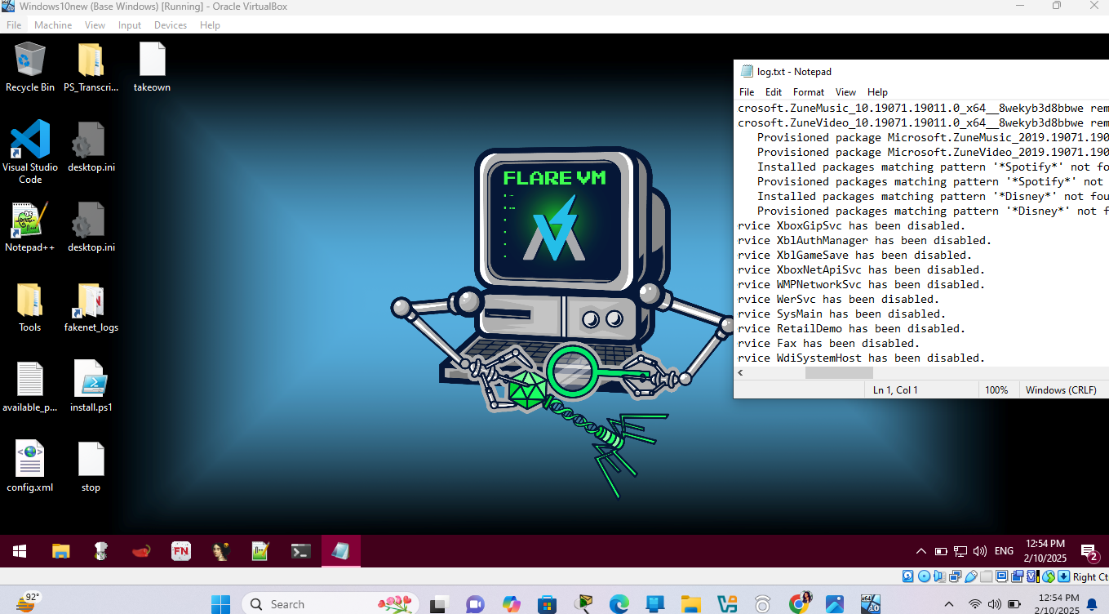

Figure 47: Flare Vm finally Installed

**Step 5: Post-Installation Configuration**

1. Switched the VM to **Host-Only Networking** mode in VirtualBox to isolate it from the internet.
2. Opened **virtual box** >> clicked on **tools**>> clicked on **create**
3. Right Clicked on the newly created network #2
4. Configured the Adapter and the DHCP Server
5. Applied the Configuration

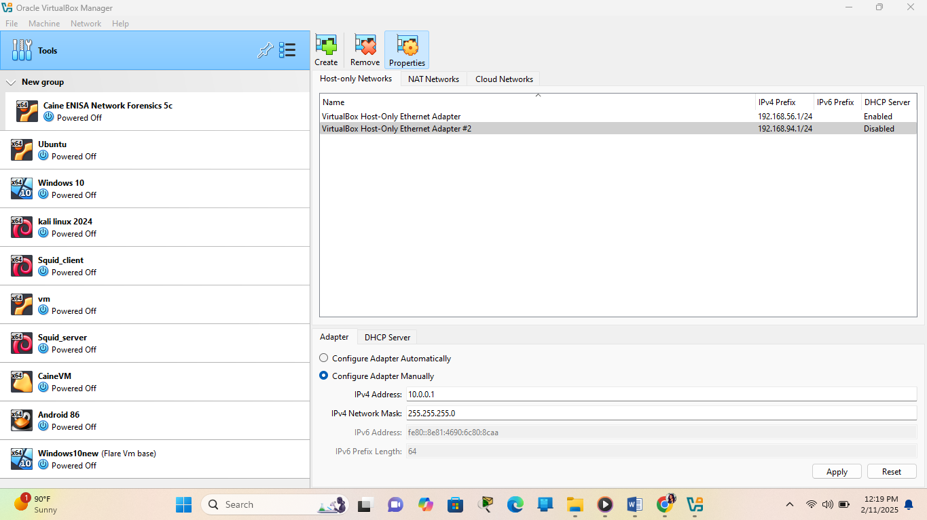

4

3

2

1111

Figure 48 : Network Adapter Configuration

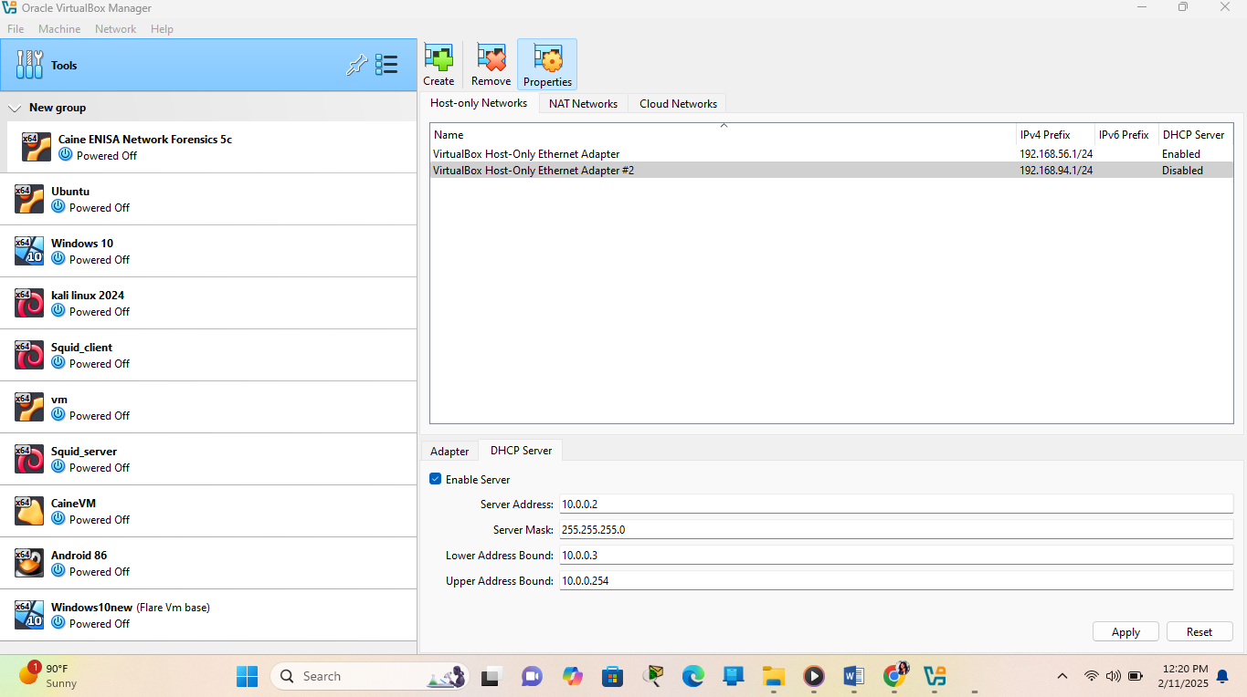

5

Figure 49: DHCP server Configuration

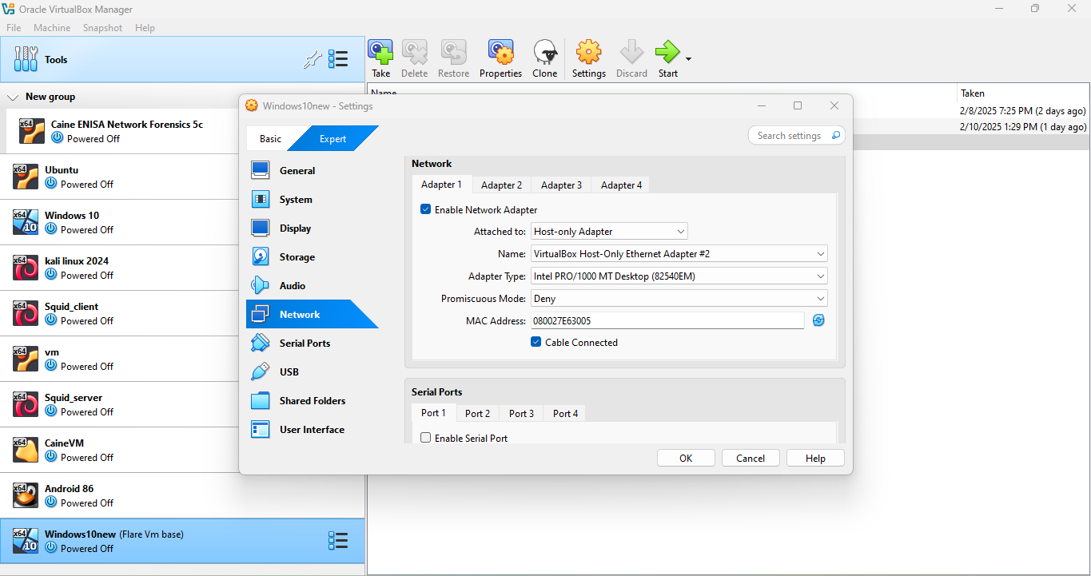

8

7

6

Figure 50:Host only Adapter Configuration

1. Take another snapshot of the VM to save the configured state.

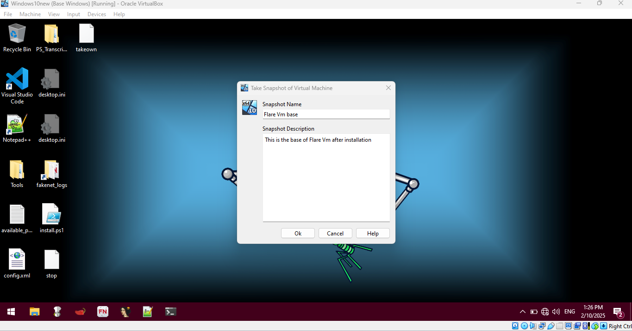

Figure 51:Flare VM Snapshot

**2.0 Analysis and Findings**

The installation of FLARE-VM was successful, and all tools were installed without errors. The virtual machine is now ready for reverse engineering and malware analysis. The isolation of the VM ensures that any malware analyzed will not affect the host system or external networks.

**3.0 Challenges and Solutions**

* **Challenge 1**: Windows Defender blocked the installation script.
  + **Solution**: Disabled Windows Defender using 3rd party antivirus defender control
* **Challenge 2**: Network delays
  + **Solution**: I kept monitoring the network and had switching between networks
  + **I also increased my Data GB to accommodate the downloads**

**4.0. Conclusion**

This lab provided a hands-on experience in setting up a FLARE-VM environment for malware analysis. The process highlighted the importance of isolating the analysis environment and disabling security features that could interfere with the installation. The skills gained in this lab are essential for advanced cybersecurity operations and threat intelligence.

**5.0 Recommendations**

* Regularly update the FLARE-VM tools to ensure compatibility with the latest malware samples.
* Always use host-only networking to prevent accidental malware execution outside the lab environment.
* Document any changes made to the VM for future reference.

**References**

* FLARE-VM GitHub Repository: <https://github.com/mandiant/flare-vm>
* VirtualBox Download: <https://www.virtualbox.org/wiki/Downloads>
* Windows 10 ISO Download: <https://www.microsoft.com/en-us/software-download/windows10ISO>